Third Year Mini Project SEM 1

**Placement Point!!!!**

**Project team:**

1. Mr. Ritesh Tanaji Herel

PRN: 2015BCS014

Ring us @:9075224249

Mail us@: riteshharel07@gmail.com

2. Mr. Sumit Prakash Garje

PRN: 2015BCS046

Ring us @:9921774951

Mail us@: sumitgarje1997@gmail.com

3. Mr. Vinit Vijaykumar Mahajan

PRN: 2015BCS052

Ring us @:9421426366

Mail us@: vinitmahajan1@gmail.com

**Guided by:**

Mr. S. S. Sontakke sir

**PROJECT TITLE:**

Placement Point

**Technical Area(s) Explored:**

Web, Android, DBMS

**Application Domain(s):**

College

**Application User(s):**

Students, Training and Placement Office

**Benefit of Project:**

* System will make the college students familiar with campus placement taking place in college
* System will make it more convenient for a student to get information in required category like students arising for placement and other students

**Assumptions:**

* PC and Android devices are available.
* Net connection is available.

**Abstract:**

In colleges, placement activities takes place. But many times the students of the college are not known with placement activities taking place in college .So, they are unaware about the companies and their criterias . So when they are going to appear for companies ,things become difficult for them.

So inorder to make students know the placement activities we are providing the system.

**Objectives & Scope:**

To provide the easier and cheaper way of getting information about the placement activities in college.

* Current Scope: College.
* Future Scope: The same application can be customized for different colleges ,career academies to provide information about placement activities.

**System Configuration:**

* + Operating System: Compatible Android Version
  + Language: html, css, php, Node JS, Django ,javascript
  + Data: Information about the Training and Placement Office
  + Database: MySQL

**Methodology**

**MODULES:**

* **Module Sign-Up:** User needs to signup to the System with

appropriate credentials like PRN ,mail id,phone number and password.

* + **Module Login:** User needs to login to the System with appropriate credentials like PRN and password.
  + **Module UPLOAD-INFO:** Here students and admin will be able to upload information.
  + **Module LookForCompanies:** Here user will be able to look for upcoming companies.
  + **Module get-Notifications :**Students will get notifications about the companies..

**Project Design:**

Use Case diagram:

Class diagram:

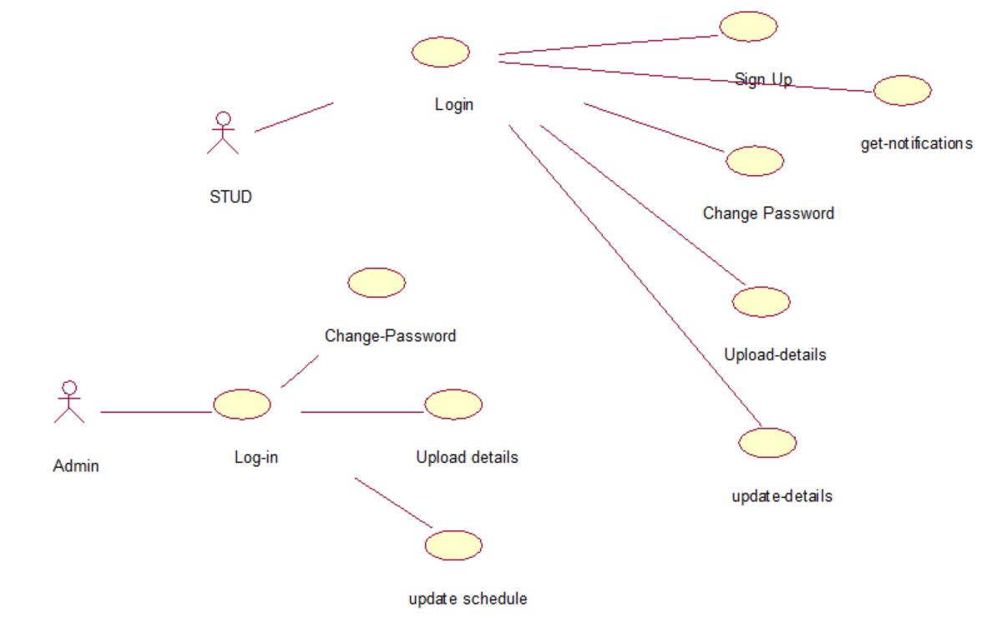

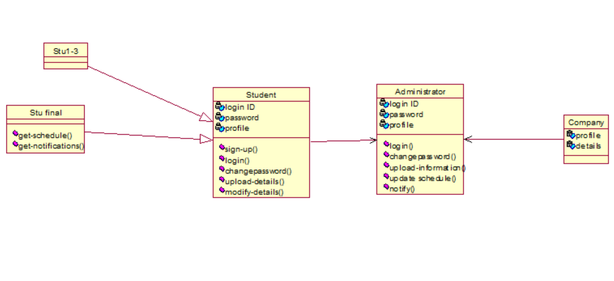

**Project Management:**

Gantt Chart